Ride for the Roses I & II
&
Hotter than Blue Blazes I & II

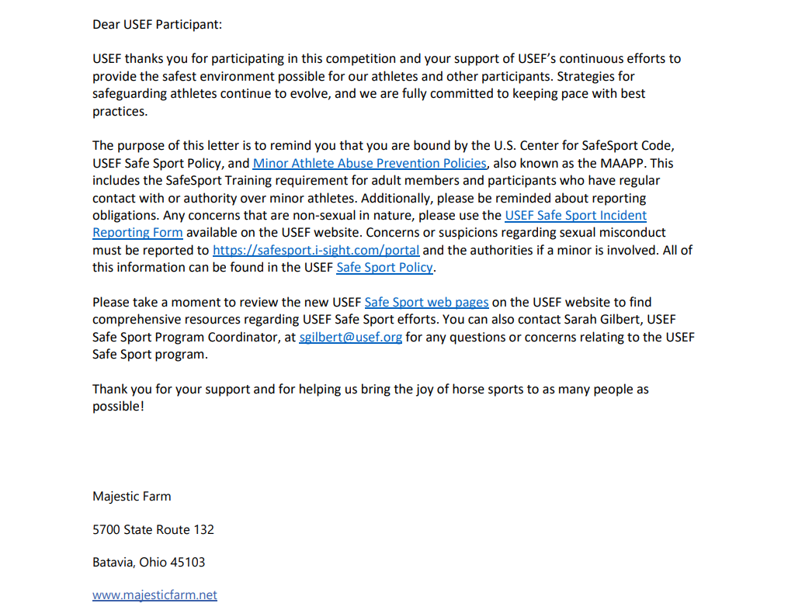
PLEASE READ

